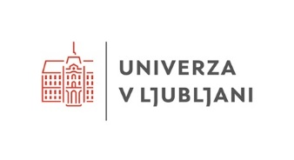
EUTOPIA Innovation Challenges for Researchers 5th - 9th May 2025

NOVA University Lisbon

Name and surname
University
Department
E-mail
LinkedIn profile (optional)
Mobile phone number
Research field(s)
Which Vertical are you most interested in? (choose at least 2) | Vertical 1: Protection and Regeneration  Vertical 2: Maritime Transport and Ports  Vertical 3: Water Management  Vertical 4: Blue Biotechnology
Do you have any specific idea and / or interest that you would like to
test / investigate within this event?
Do you have any questions you
would like to post before the event?
Motivate your application in max 200 words.
Why do you want to go to the Innovation Challenges for Researchers event in Lisbon?
Tip: Go beyond your research. Be original.

GDPR Consent

I have read and agree that the organisers of the event:

- may take/record multiple photographs/videos during the event for the purpose of promoting or reporting on the event. The photos and recordings of the event may be published on the organisers' websites and on social networks (e.g. LinkedIn, Facebook, YouTube or Instagram).
- My personal data: Surname, first name, e-mail address will be processed for the purposes of the EUTOPIA Innovation Challenges event (possible additional notification and sending of reminders, subsequent sending of materials and surveys) and for the creation of a list of participants to verify participation in the event.
- The eventual list of participants with my personal data: Name, surname, institution and e-mail address will be forwarded to the co-organisers, partners and other participants of the event in order to connect the participants.
- NOVA University Lisbon (NOVA Impact office) will stop processing the above-mentioned personal data after 3 (three) years from the date of the event.
I can revoke my consent to the use of my personal data at any time by sending an e-mail to novaimpact@unl.pt. I understand that the withdrawal of my consent does not affect the lawfulness of processing based on consent before its withdrawal.
- I have read and agree to the NOVA University Lisbon’s Privacy Policy (https://www.unl.pt/en/data- protection/).
- For further information, please contact dpo@unl.pt.

